Principle of flight

**Subsonic aerodynamic**

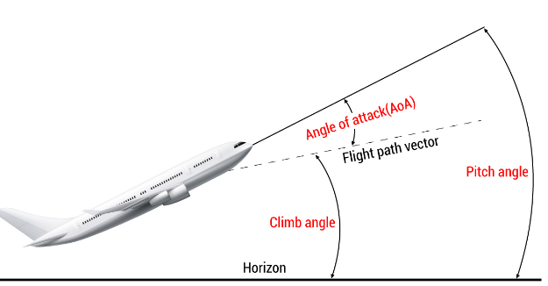**2D airflow**

**Wing AOA** = chord + relative airflow (speed vector)   
**Airplane AOA** = longitudinal axis + relative airflow (speed vector)   
**Angle of incidence** (AOI) = wing root chord + longitudinal axis

**Flight path angle** (FPA) = horizon – speed vector (flight path)

**Pitch angle** = horizon – longitudinal axis = AOA + FPA

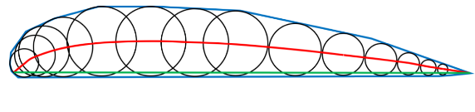**Maximum thickness** of a chord is expressed as a % of the chord length (tMAX/c) and a thicker profile has a greater CL at the same angle of attack compared to a profile less thick

**Cambered airfoil**: the line connecting all the inscribed circles is curved

**Tapered wing** (Rastremata) = Tip chord/Root chord **<1**

**Aspect ratio** (allungamento) = b2/S = b/c = C2L / CDI [b = wing span; S = gross wing surface; c = mean chord]

**Mean geometric chord** = MAC = S/b (chord of a rectangular, unswept, untwisted wing with no dihedral/anhedral whose profiles and wing area is exactly the same as the original wing)

**Wing washout** = wing root AOI > wing tip AOI so that wing root stalls before wing tip

Equation of continuity: ṁ = ρSv = constant (mass flow rate = constant)

**Lift is perpendicular to the relative airflow/wind**

**Drag is parallel to the relative airflow/wind**

CD = C­D0 + K*C2L = C­D0 + CDI | CDI = K*C2L

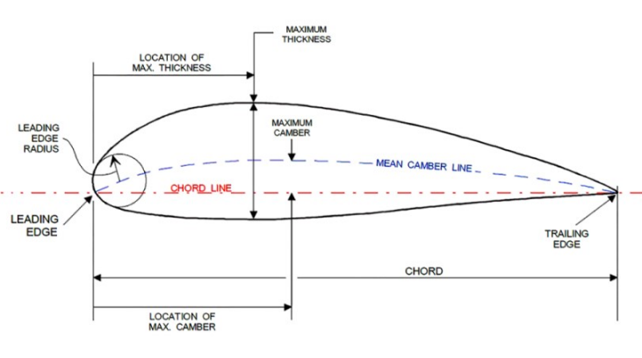

Load factor N and CL are directly proportional and Vfinal = VInitial

**Increasing the AOA**: [IDF]

* Stagnation point moves DOWN
* 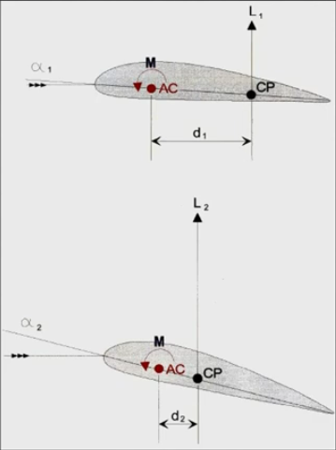Point of lowest Static pressure moves FORWARD and is where there is maximum dynamic pressure

**Aerodynamic center** is independent of the AOA and is at 25% of chord line and is where moments are the same. It is always **ahead of the center of pressure.**

**Center of pressure (CP) for a cambered airfoil**:

* Moves FORWARD when AOA increases
* Moves AFTERWARD when AOA decrease

For a symmetrical airfoil, the CP is independent of the AOA and is at 25% of chord line

Maximum L/D = 16°  
Maximum CL/CD = 4°

In EASA world D/S = drag pressure

The highest value of CL/CD ­ is obtained in a clean configuration

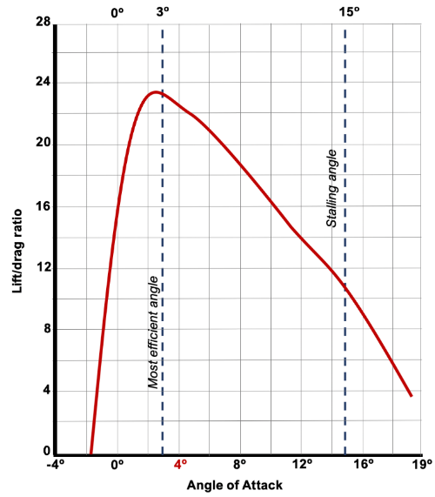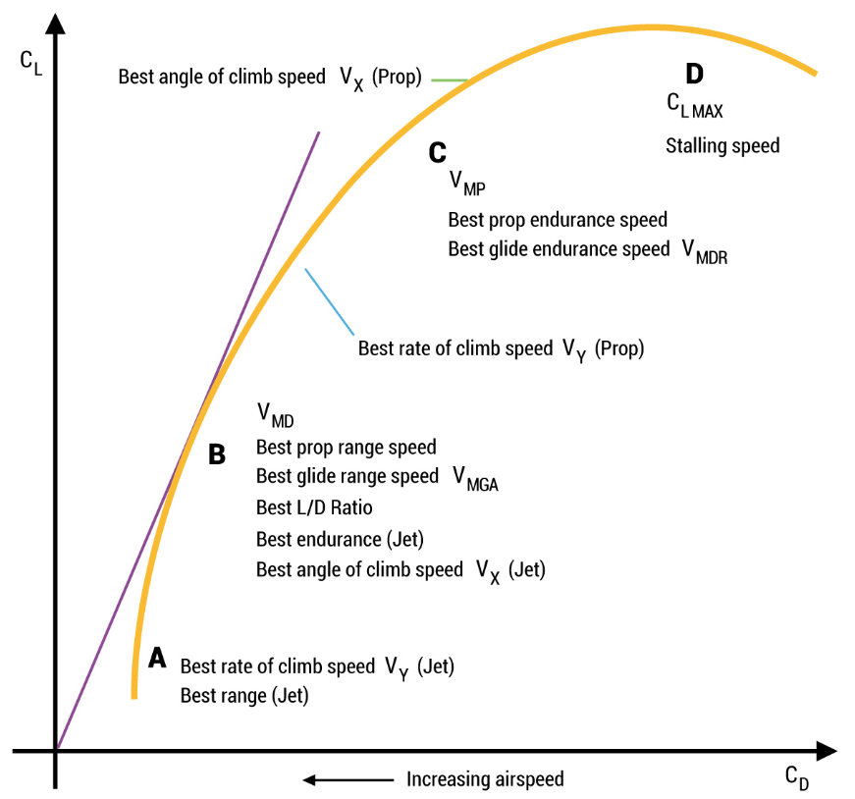Wing tip vortices are stronger in a heavy, clean, and slow configuration

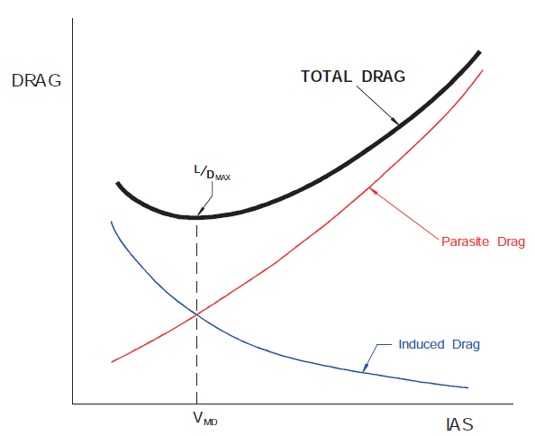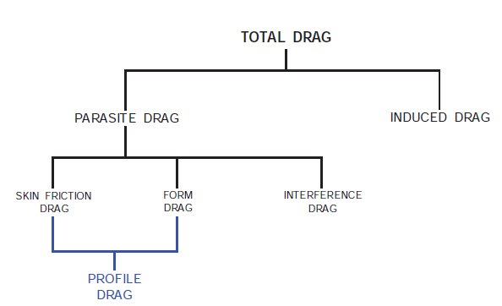**3D airflow**

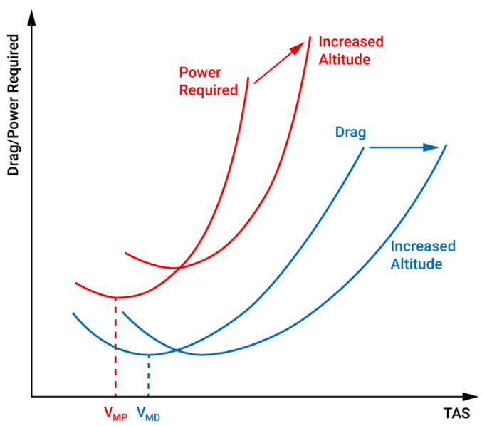

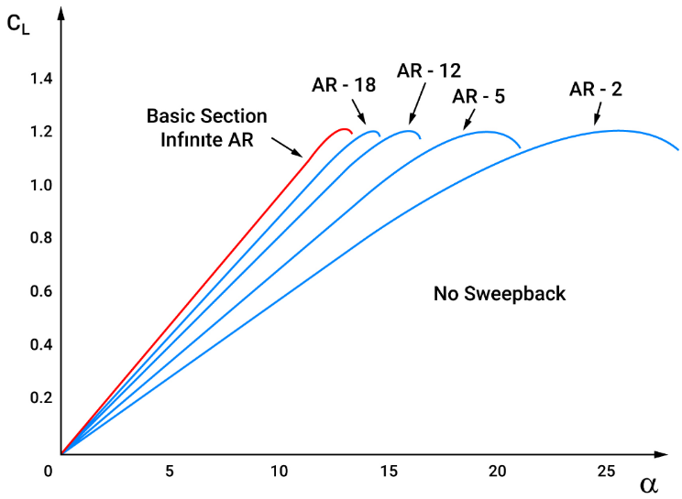The decrease in upwash/downwash will cause the induced AoA to decrease leading to a decrease in induced drag, while the effective AoA increases.

**Wing tip vortices intensity increases**:

* As Aspect Ratio decreases
* With increasing AOA

**Induced drag increases when**:

* Speed decreases
* Mass increases

When **below the VMD** the aircraft will be in the **unstable speed region** and a reduction in air speed will cause an increase in total drag

**Lowest induced drag wing form is the elliptical**, because the downwash remains constant across the complete wingspan.

An **elliptical wing** produces **more lift closer to the root**

Difference between a 2D and a 3D flow about a wing is that a spanwise component exists in addition to the chordwise speed component

The greater the downwash, the greater the lift being generated by the airfoil.

Same IAS = Same Drag | Same TAS = Different Drag (at different altitudes)

VMD = speed of minimum descent angle

VMP = speed of minimum power = minimum sink rate speed | VMP is lower than VMD

**Ground effect**

**Entering** ground effect: lift increases, induced drag reduces, induced AOA decreases. effective AOA increases

**Leaving** ground effect: lift reduces, induced drag increases, induced AOA increases, effective AOA decreases

It starts **developing at half wingspan** from the ground

**Critical AOA** when in ground effect is **decreased**

Winglets reduce the size of the wing tip vortices and consequently the ground effect will decrease too.

When there is a hot day, the increased temperature of the runway will add to the consequences of entering ground effect. The convective currents from a warm runway will add to the upward forces caused by the ground effect.

**CL MAX Augmentation**

* Slotted flap: have greater CL MAX than plain or split flaps and generate less drag (re-energize the airflow)
* Split flap: increases drag heavily due to open trailing edge
* 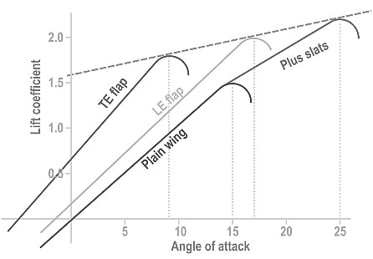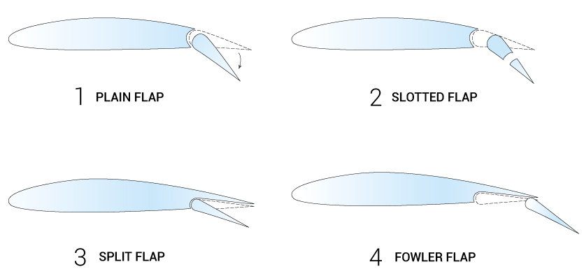Fowler flap: increased lift by large amount and increased drag compared to plain flap, but lift increase >> D increase. It is the most effective flap as it increases wing area.

**Flaps**: More influence on CL/CD Ratio | | TE = nose down tendency  
**Slats**: More influence on CL MAX | Nose up tendency (only increases CL MAX )

From clean configuration, extending TE flaps the airplane climb and pitch down

Increasing CL/CD Ratio for flaps:

* Plain
* Split
* Slotted
* Fowler

When **flaps asymmetry** occurs, roll towards the flap more extended and yaw opposite direction

When **slat asymmetry** occurs, the wing with slat retracted could stall shortly after rotation

During asymmetry:

* Slat generates a yawing moment
* Flap generates a rolling moment

Lowering trailing edge flaps reduces wing tip vortices due to CP being closer to the wing root

A deployed slat increases the boundary layer energy and increases the suction peak on the fixed part of the wing, so that the stall occurs at higher AOA.

Slat extended gives a large decrease in stall speed with relatively less drag. That’s why they are retracted after flaps.

**Vortex generators** re-energize the lower layer of the boundary air, **delaying the separation** point to **further aft** along the airfoil surface. They also increase the critical AOA

**Increased downwash (due to flap extension**) will result in a **higher angle of attack of the tailplane**, **increasing its effectiveness** and producing a greater lift and causing a nose-up pitching moment

With a lower flap setting than required (15 instead of 30), landing distance may be insufficient and a tail strike is more likely.

If trailing edge flap remain extended after a go around, there are degraded climb performance and possible VFE exceedance

In the event of a flap overspeed, a flap load relief system will retract the trailing edge to an intermediate position

**Movement of Center of pressure** during straight and levelled flight and **decreasing speed** for different airfoils:

* Cambered: move forward and after the stall move aft
* Straight: moves aft
* Sweptback: move forward and after the stall move aft

**Speedbrakes** will:

* Increase ROD
* Increase Descent angle.
* Increase stall speed
* AOA increases for a constant CL

Speedbrakes polar will decrease and move to the right when extended.

**Roll spoilers** decrease the lift of the downward-going wing and reduce the adverse aileron yaw

For ice accretion the effect is much more pronounced when the items are sharp, instead of curved

The CP moves FWD if the angle of attack is increased up to the critical angle of attack. Beyond that it moves AFT on a straight wing

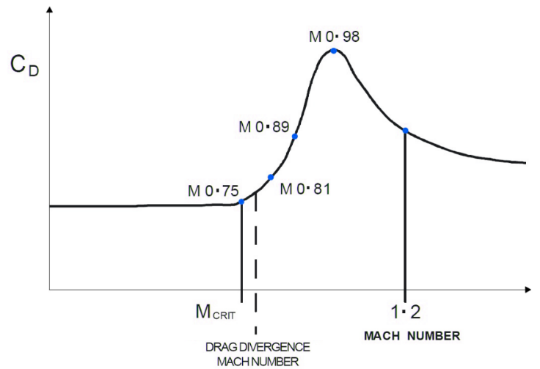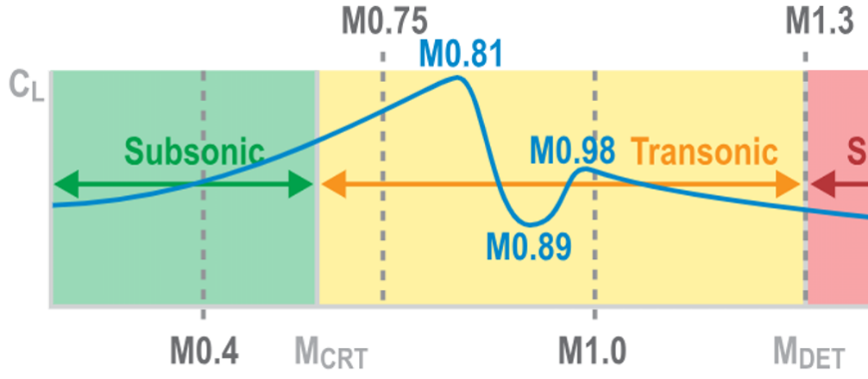**High speed aerodynamics**

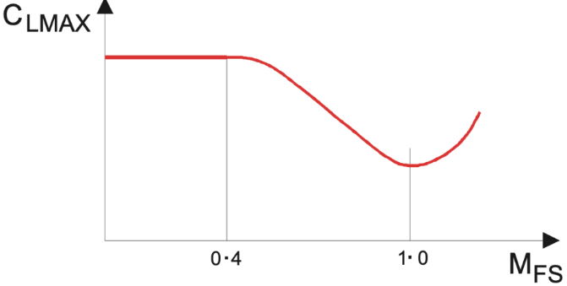According to EASA, ‘’above tropopause’’ = ‘’in tropopause’’

Speed of sound: $LSS=c=38.95\sqrt{T}$

IAS=1/2∗ρ∗TAS2

When flying into a colder air mass at constant IAS/CAS, TAS decreases and LSS decreases, so Mach stays constant

When flying into a hotter air mass at constant IAS/CAS, TAS increases and LSS increases, so Mach stays constant

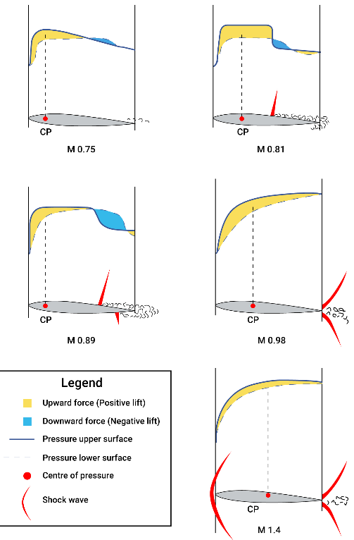At lower altitudes, the MMO/VMO becomes a structural limitation (risk of overstress)

At higher altitudes, the MMO/VMO becomes an aerodynamic limitation (we are close to buffet boundary)

During a descend at constant Mach, TAS increases to compensate for the increasing temperature and the AOA will decrease

During a descend above the tropopause at constant Mach, TAS is constant and CL will decrease (increase in climb)

A **supercritical airfoil** has:

* a much flatter top surface
* a larger leading-edge radius
* both positive and negative camber

which not only increases MCRIT​​​​​​​ and MDD (drag divergence) but also creates a weaker shockwave when one is formed, just above MCRIT​​​​​​​.

The shockwaves on a supercritical airfoil quickly move to the trailing edge, making the shock stall a much smaller effect. The main benefit is the faster speed that can be flown, before drag increases due to wave drag.

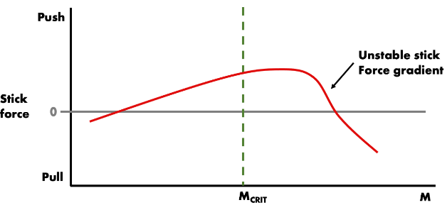Signals of reaching and surpassing MMO can be felling a vibration through the fuselage structure, with pilot feet resting on the floor.

The Mach number can be determined using dynamic pressure and static pressure alone.

High speed buffet occurs above M = 0.84 with a rapid

* Decrease in CL
* Increase in CD

MCRIT is the highest flight speed where there is no supersonic flow over any portion of the airfoil.

Above MCRIT CP moves aft giving a nose down pitching moment called **Mach Tuck or Tuck Under** (that can be mitigated using Mach trim, shifting CG aft in trim tanks) and reduced stick stability (if no control augmentation is present, aft movement of the stick is required to compensate for the pitch down moment)

Best specific range is achieved by cruising just above MCRIT, and by flying as high as other considerations permit.

|  |  |  |
| --- | --- | --- |
|  | Normal shock wave | Oblique shock wave |
| Airflow speed | Subsonic | Supersonic |
| Airflow energy | ↓ | ↓ |
| Total pressure | ↓ | ↑ |
| Static pressure | ↑ | ↑ |
| Density | ↑ | ↑ |
| Temperature | ↑ | ↑ |
| LSS | ↑ | ↑ |

As Mach increases, CP reaches 50% of the chord and a shock wave forms in the lower part of the airfoil moving aft faster than the shock wave in the upper part.

At a speed just below the MCRIT the total pressure will increase slightly due to compressibility of the air which, for example, gives an artificially high reading of CAS

**Deflecting a control surface upward decreases camber will make the shockwave to move forward due to the increase in MCRIT.**

The intensity of a shockwave increases as AOA increases.

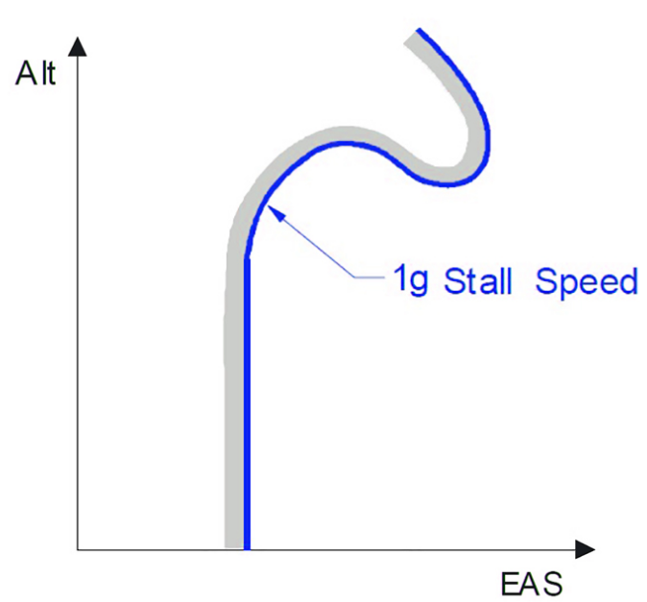MCRIT is inversely proportional to AOA

The **Drag Divergence Mach number** = **Mach Drag rise** is the Mach number at which the aerodynamic drag on an airfoil or airframe begins to increase rapidly as the Mach number continues to increase

As altitude increases, **stall speed** is initially constant then increases, due to compressibility.

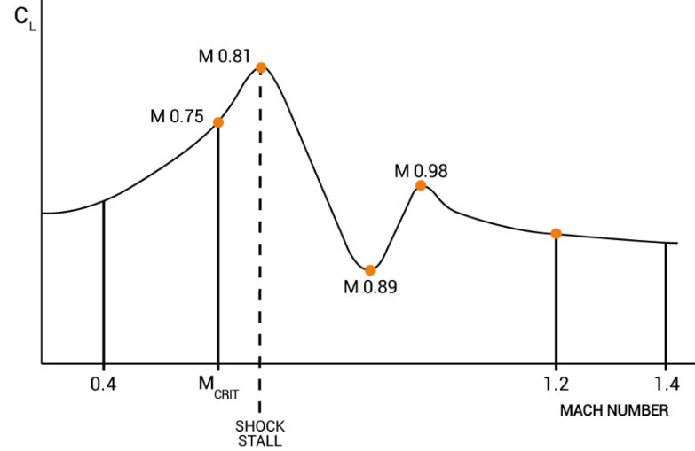**Shock stall**, also called **Shock induced separation**, results from a separated boundary layer just as the low-speed stall does. Unlike the normal high-incidence angle stall, it occurs at low AOA and at an unexpectedly high IAS. For swept-wing airplanes because the wing-tips stall first the airplane has a nose-up pitch tendency. The AOA of the high-speed shock stall decreases as the Mach number increases. Shock stall occurs (after) CLMAX is reached as a function of Mach number for a given AOA.

In transonic flight the **ailerons are less effective** than in subsonic flight because aileron deflection only partially affects the pressure distribution around the wing.

In the **transonic** region, the **CL / CD ratio is reduced**.

Wave drag is due to energy drag and boundary layer separation (separation drag)

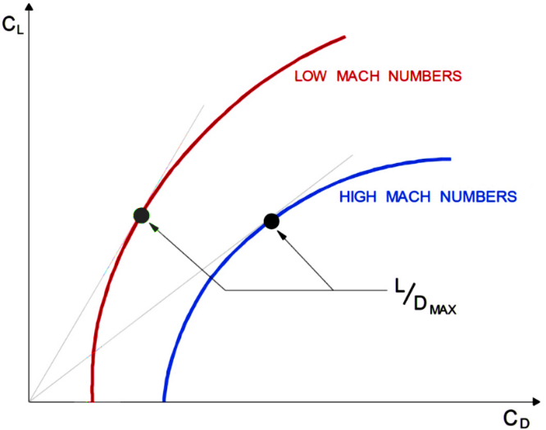**Supersonic flight** is usually accompanied by large **increases** in **static longitudinal stability** (due to aft CP movement) and a reduction in the effectiveness of control surfaces (**reduced speed stability**).

Higher mass = lower MCRIT due to a greater AOA to maintain a level flight at a given speed.

To reduce friction drag, wings are designed to delay the transition point and have a larger laminar flow

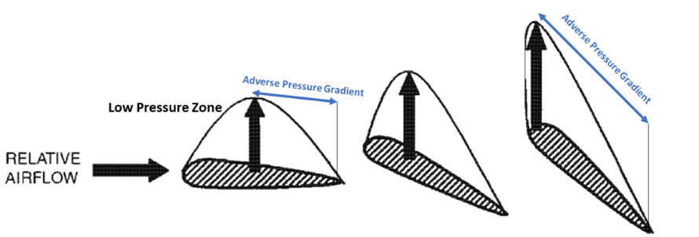The area covered by an **adverse pressure gradient** on the top of the airfoil gets larger with **increasing angle of attack**, and the pressure gradient **gets stronger** also. The **air in that area** will have lower energy, and therefore **lower speed** due to this, eventually **causing the stall from TE**

A **Swept Wing** Increases MCRIT (only advantage)

The air velocity perpendicular to the wing span is reduced and corresponds to the free stream velocity multiplied by the cosine of the sweepback angle. **Swept wing increases the effective aerodynamic chord for the same dimensional thickness.**

When compared to a straight wing of the same section, **a swept wing is less aerodynamically efficient**:

* At a given angle of attack CL is less, which **increases the stall speed**
* **CLMAX is less** and occurs at a higher angle of attack
* The lift curve has a smaller gradient (change in CL per degree change in alpha is less)
* Increased tendency to **stall at the tip first**
* Must be fitted with **complex high lift devices**, both leading and trailing edge, to give a reasonable take-off and landing distance (**higher Takeoff and landing distance** but more efficient Trailing Edge control surfaces). The bigger the swept angle, the lesser the efficiency of high lift devices
* 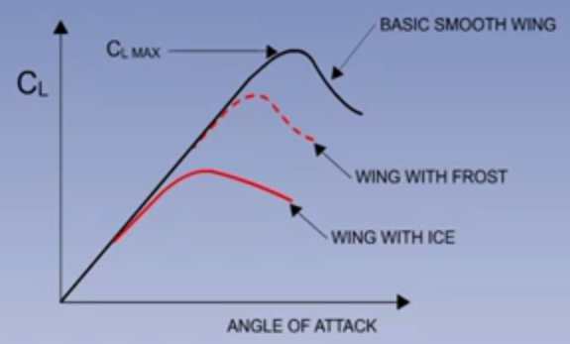Must be **flown at a higher angle of attack than a straight wing** to give the required lift coefficient; this is most noticeable at low speeds

**Stall**

**VSR** is the reference stall speed (CAS)

The tail plane is normally operating at a negative angle of attack, producing a download, so if the tail plane stalls and the download is lost, the nose of the aircraft will drop, and longitudinal control will be lost.

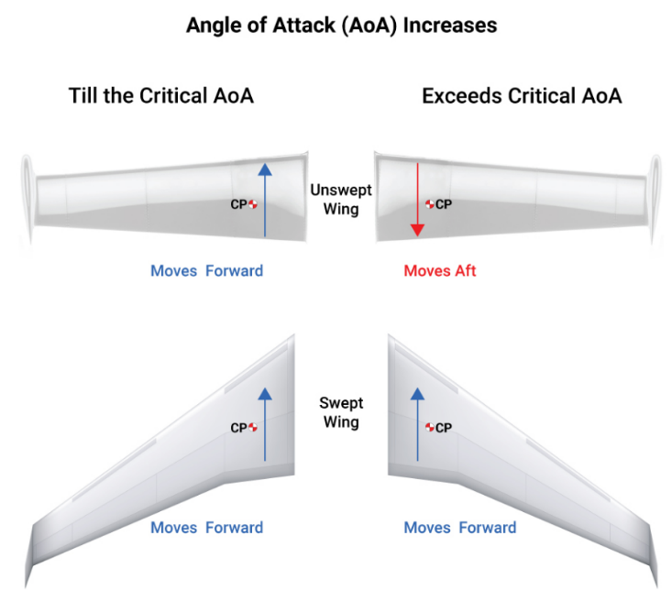Stalling of an ice contaminated tail plane could be precipitated by extension of the wing flaps. Lowering the flaps increases the downwash, and this increases the negative angle of attack of the tail plane. If the tail plane has ice contamination, this could be sufficient to cause it to stall. Recovery procedure in this situation would be to retract the flaps again, thus reducing the downwash.

Swept-back wing + T-tail = prone to deep stall

In a **swept-back wing** in a stall, the **pitch up** effect is due to wing tip stalling first

In a **straight wing** in a stall, there is a **pitch down** moment

During a spin, never look at the balance ball, but at the turn indicator needle

**Deterrent Buffet**: the airplane exhibits sufficient buffet that the flight crew will be deterred from commanding even higher AOA. Caused by high AOA.

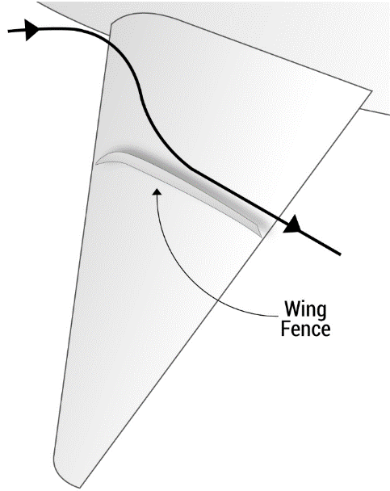Behind the transition point in a boundary layer, the mean speed and friction drag increases

$$N=\frac{L}{W}=\frac{1}{\cos\left(α\right)} \left| \frac{C_{Lnew}}{C_{Lold}} | V_{new}= V_{new1G}*\sqrt{N} \right| V_{s_{new}}={V_{s}}_{old}*\sqrt{\frac{m_{new}}{m_{old}} }$$

**Wing fences** prevents the outward drift of the boundary layer and thus reduces the tendency to tip stall. This will allow flying at higher angles of attack, i.e. fly slower.

**During a turn**, the **inner wing** is **slower** than the outer wing and a **stall** towards the inside is most likely

The **more AFT the CG**, the **flatter the spin**. If the **CG is FWD**, the aircraft will naturally tend to point the **nose down** and have a higher Vs

In the first stage of a spin, spinning motion and forces have not been equalized yet.

In a fully developed spin, speed is low and constant and spinning rate is constant.

If thrust increases, stall speed decreases as a part of the thrust itself has a vertical component, supporting the weight and reducing the lift generated by the wing

An aircraft with right-turning propeller (clockwise rotation) when stalling enters an incipient spin to the left due to the propeller (remember on takeoff you use right rudder)

**Vortilons** are fixed aerodynamic devices on aircraft wings used to **improve handling at low speeds** (high AOA). When the wing approaches stall, span-wise flow starts to flow across the vortilons which start to generate a vortex. The vortex energizes the boundary layer over the wing. The turbulent flow in the boundary layer delays the flow separation resulting in increased controllability of the airplane in stall.

Extension of trailing edge flaps increase downwash and the risk of premature stall

**Buffet Margin** is the difference between High and Low speed buffet.

**Buffet Margin** increase with (decreases with the opposite factor below):

* Decreasing Altitude
* Decreasing Mass
* Decreasing Bank Angle
* Decreasing Load Factor

**Coffin corner** is the point where High-speed buffet and Low-speed buffet meets, so both an increase and decrease in speed is not possible without either exceeding MMO or enter a stall. The solution is to reduce altitude

Maximum allowed cruising altitude based on a 1.3g margin is the altitude where a maneuver with a load factor of 1.3g will cause buffet onset.

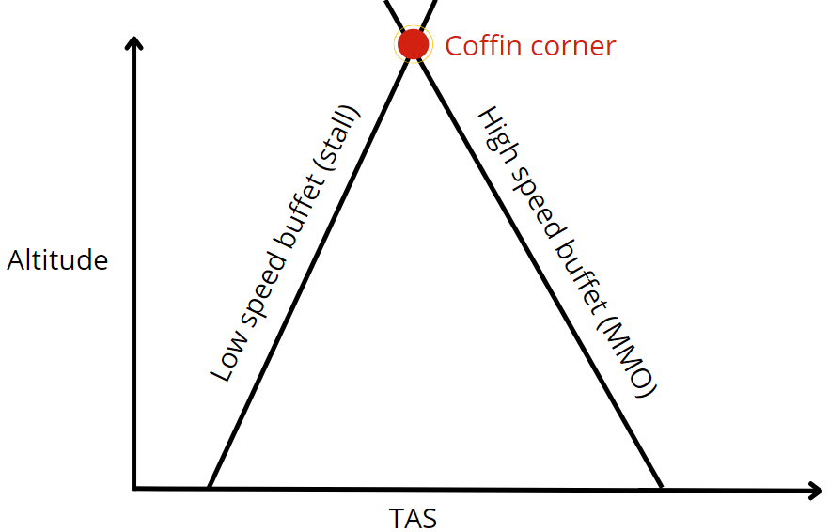If in a turbulence, fly at turbulence penetration speed and descent from current altitude to increase stall speed margin.

In a microburst the airplane may stall due to increased tailwind

**Static and Dynamic Stability**

**Neutral point**: the point between the ADC of the wing and tail where wing moment and tail moment are equal

As an aircraft static stability increases, an aircraft equipped with a particular size of control surfaces may experience a slight reduction in maneuverability.

CG AFT = - static stability | + maneuverability | stick force decrease | elevator authority (and deflection) increases

CG FWD = + static stability | - maneuverability | stick force increase | elevator authority (and deflection) decreases

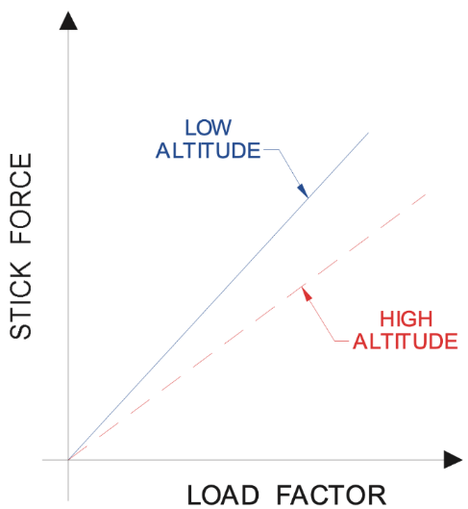Every stability is reduced when the CG moves AFT

An AFT CG means a lower stick force gradient (also called stick force per g)

Stick force stability is the force required to hold a different airspeed

During a climb, stick force gradient decreases

If in a FBW aircraft a more FWD CG is selected instead of a more AFT CG, the actual longitudinal stability is lower than calculated and the system may allow for control surface deflections that results in instability

Highest value of wing lift occurs for FWD CG and low thrust

Engine nacelles of an aft fuselage mounted engine have a positive contribution to static longitudinal stability

A T-tail is more stabilizing than a low tailplane because it is less affected by downwash behind the wings

Phugoid is usually poorly dumped + AOA variation not significant but altitude change significant

Short period is usually heavily dumped + AOA variation significant but altitude change not significant

A pilot in flight can change the CM/alpha graph by:

* Changing the center of pressure by moving flap setting
* Changing the center of pressure by varying alpha

For directional stability, when the CG moves AFT, less distance between tail and CG means more force is needed

Directional stability can be improved by using a dorsal and ventral fin. They become more effective at relatively high sideslip angles.

Increasing the dimension of the fin, increase lateral and directional stability

An airplane has directional static stability if, when in a sideslip with the airflow coming from the left initially the nose tends to yaw left.

Excessive directional stability may give controllability problem when flying with sideslip

**Sweepback fin** or low aspect ratio **increases the stalling AOA of the fin** and reduces the lift curve slope, therefore **reducing static directional stability**

**Sweepback wing** increase static directional and lateral stability

Sideslip angle: angle between the plane of symmetry and the speed vector (positive sideslip = nose to the left).

Lateral stability too low: If lateral stability is lower than adequate, the aircraft simply does not get back to 0º bank angle in time, thus deviation from the position and altitude is excessive.

Lateral stability too high: An excessive lateral stability can cause problems during crosswind landings/take-offs because an excessive roll input is required. A high static lateral stability reduces controllability in roll.

Dihedral allows for increase in lateral stability (increased lift on the wing into the wind)

Anhedral allows for a reduction in lateral stability when the aircraft is excessively stable

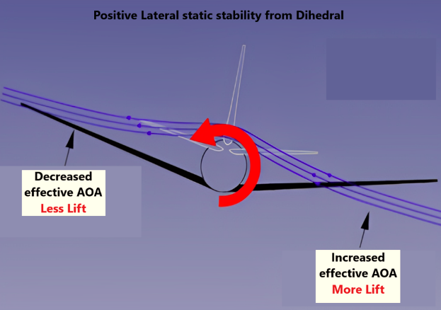The airplane design features that **increase the lateral static stability** are:

* dihedral
* sweepback
* high-wing mounting
* increased effective dihedral
* large, high vertical fin
* low CG

The airplane design features that **decrease the lateral static stability** are:

* anhedral
* forward-swept wings
* ventral fin
* low-wing mounting
* extending inboard flaps

**Dutch roll** occurs when a **strong lateral stability** is coupled with **weak directional stability**

Dutch roll occurrence may increase with increasing altitude (decreasing density) or increasing Mach number. If yaw dumper is INOP, it is advisable to reduce speed and altitude.

In Dutch roll, a shockwave tends to yaw the aircraft at speed above MCRIT

Lateral and directional stabilities interact through sideslip, which is created when using either aileron or rudder alone.

If the airplane has low static lateral stability, it is more prone to controllability problem in roll and yaw

Spiral dive is a non-oscillatory and the airplane will roll and yaw in the same direction

As high altitudes the airplane is subject to a decrease in aerodynamic dumping, contributing to a decrease in dynamic lateral/directional stability

**Pitch, Roll, Yaw Control**

Elevator moving upwards = increased negative camber of tailplane and elevator + negative lift

Elevator moving downwards = increased positive camber of tailplane and elevator + positive lift

Frise ailerons reduce adverse yaw. The leading edge of the up-going aileron protrudes below the lower surface of the wing, causing more drag (because the down-going aileron generate more lift and so more induced drag).

With differential ailerons, the up-going ailerons deflection is increased more than the down-going aileron to generate more drag and so to allow for a compensation of the adverse yaw (up excursion is more than down excursion)

Anti-ice fluid can build up between the elevator and the horizontal stabilizer making the controls more heavy

When the wing AOA increases, downwash causes the horizontal tailplane to experience a lower increase in AOA

Rudder ratio or travel changer is used to prevent excessive rudder excursion at high speed

Aileron reversal can occur at high speed when the wing twists as a result of the loads caused by operating the down-going ailerons. Inboard ailerons are used to avoid this.

T-tail is less affected by downwash so it is more stabilizing than low tailplane.

Aileron deflection affects roll rate and is dependent on IAS.

Flaperons = flap + ailerons

**Balance tab:** reduce stick force, moves in opposite direction to control surface. Acts in reversal as it deflects opposite direction to control surface itself.

**Anti balance tab:** increase force needed to move control surface (when stick force is too light).

**Servo tab:** serves pilot directly, acts the same as balance tab but it moves the control surface which can be dangerous as you do not know if the actual control surface is frozen. it acts in reversal as it deflects opposite direction to control surface itself. It enables big control surface movement with relatively small force needed to apply.

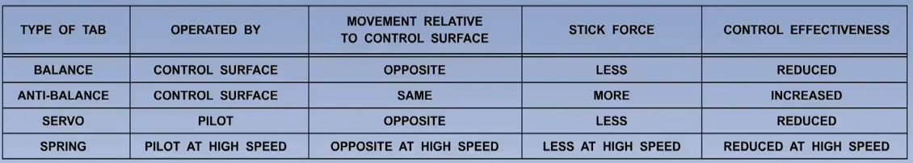**Spring tab:** causes the tab to move in the opposite direction to the main control surface at an ever-increasing angle, which is directly proportional to the increasing airspeed. It assists the pilot by reducing the stick force required to operate the main control surface to a similar level for all airspeeds. At high IAS, the spring tab behaves like a servo-tab.

Examples of aerodynamic balancing of control surfaces are:

* servo tab
* spring tab
* seal between the wing trailing edge and the leading edge of the control surface

With a fully powered flying control the pilot is unaware of the aerodynamic force on the controls (aerodynamic limit), so it is necessary to incorporate “artificial feel" to prevent the aircraft from being overstressed.

In a power assisted flight control system, most of the force is provided by the hydraulic system

**Trim**

**Elevator trim** consists of the entire elevator moving to trim the aircraft. The main disadvantage is that it is more complex and heavier and is more sensitive to flutter.

The **trimmable stabilizer's** primary advantage is that it provides tremendous trimming power over the full speed range of the airplane since the entire stabilizer may be moved to trim the aircraft.

**Trim tab** consists of only the tab to move to trim the aircraft while the elevator is not moved.

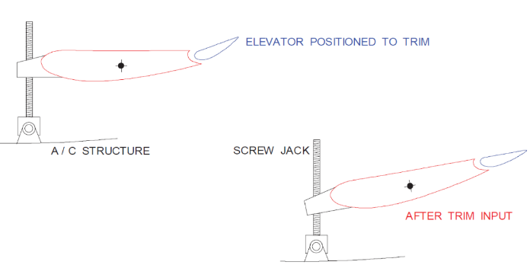In a FBW system only soft protections can be overridden

If an airplane is trimmed ‘’nose up’’, the stabilizer is up, while the elevator is in line with the stabilizer (because no input from the pilot is done as it is trimmed)

In case of go-around, the pilot should be prepared to apply nose down or trim nose down to prevent excessive pitch up caused by the additional power

In an in-trim position, with Fully powered elevator deflection is zero and with power assisted elevator deflection is dependent on speed, the slats/flaps position and the CG.

The aircraft may need to be trimmed in pitch as a result of:

* changes of speed
* changes of power
* varying CG positions
* changes of configuration

If an aircraft if configured and trimmed for take-off with a jammed stabilizer, the aircraft will remain trimmed as long as there are no major changes in speed, power/thrust, CG position or configuration.

In a FBW system, if one level of degradation occurs, the autopilot ay or may not be available, depending on the specific failure.

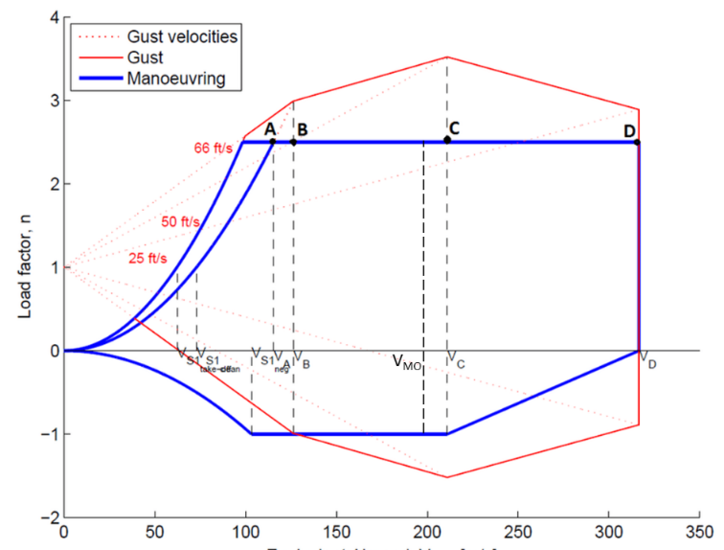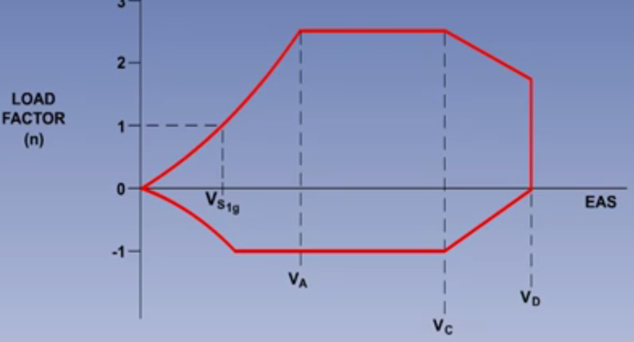**Limitations**

The increase in load factor is inversely proportional to the wing loading [W/S ↓ Load factor ↑]

Wings having a low aspect ratio, or sweep, will have a lower lift curve slope, and so will give a smaller increase in ‘g’ when meeting a given gust at a given TAS [CL/α curve slope ↑ Load factor ↑]

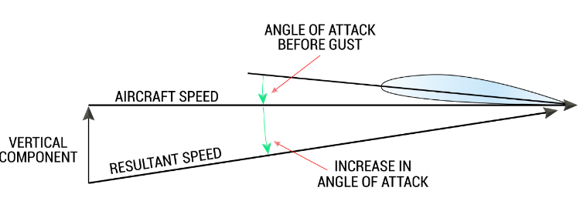Design Gust speeds for the gust diagram:

* VB (max gust intensity speed): ± 66 ft/sec
* VC (design cruise speed): ± 50 ft/sec
* VD (design dive speed): ± 25 ft/sec

The principal effect of gusts is to increase and decrease AOA. This in turn varies CL and load factor

In a vertical gust the change in AOA is proportional to the ratio of TAS/vertical gust velocity. [ΔAOA↑ Load factor ↑].

$$\tan\left(ΔAOA\right)=\frac{Vertical gust velocity}{TAS}$$

At high altitudes, with reference to sea level, TAS increases and the effect of a vertical gust velocity decreases.

The legislation that states that VNE is **LOWER** than VD and **NOT LESS** than 0.9 VD

VNE is set below VD and speed should never exceed 0.9 VD | VD is Dive speed

**VA**: Design Maneuvering Speed at which an airplane will stall before exceeding its maximum load limit. The highest speed at which sudden, full elevator deflection can be made without exceeding the design limit load factor. At high altitudes it may become unreliable as higher stall speed and low control forces make it easier to produce high load factor.

Practicing stalls, **not to stall again due to the increased load factor**, the aircraft may be operated between VS and VA

**New VS = | VA =**

Limit load factor does not change with weight

**Load factor limitations:**

* CS-25: 2.5 | -1
* CS-23:
  + Normal: 3.8 | -1.52
  + Utility: 4.4 | -1.76
  + Aerobatic: 6

**Flutter dumping of control surfaces is obtained by mass balancing in front of the hinge**

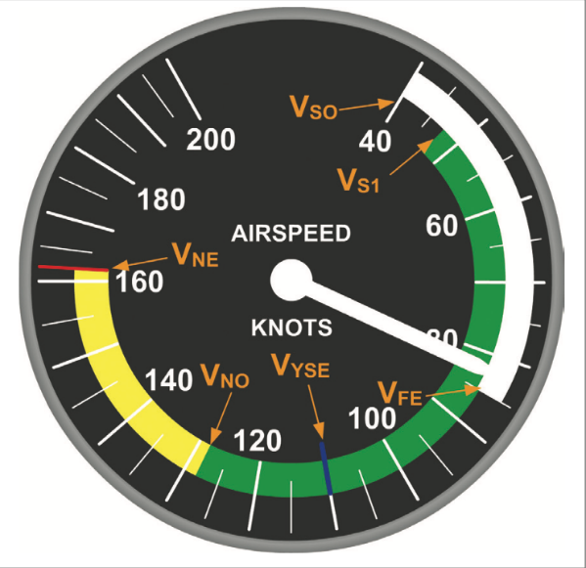**VLO**: landing gear operating speed (also transit). It is used if at VLE the aerodynamic loads could make operations of the landing gear unsafe

**VLE**: landing gear extended speed (> VLO)

**VFE**: Flap extended max speed

**VMO/MMO**is the Maximum Operating Speed and must not be deliberately exceeded in any flight condition unless a higher speed has been authorized for a particular flight (e.g. flight test).

VMO / MMO Applies for both CS-23 (as long as they are turbine powered) and CS-25

**VNE** is used only by CS-23 aircraft

So, CS-23 aircraft can use either VNE or VMO/MMO, depending on the particular aircraft.

**VRA** for use as the recommended turbulence penetration air speed and it will not cause the overspeed warning to operate too frequently.

**VC**is the Design Maximum Cruising Speed which is a speed used during testing and certification to assess the structural strength of the airplane. It is the design speed which then has a safety factor applied to give VMO

VMO < VC → VC*K = VMO [K < 1 safety factor]

**VB**: Design Speed for Maximum Gust Intensity, where an aircraft must be able to manage a gust of up to 66 ft/s.

**VD: Design Dive Speed**, the maximum speed that the aircraft can handle in a dive, often limited by vibrations, buffet or flutter. This is the absolute speed limit of the airframe.

**VMCA**: is the CAS, at which, when the critical engine is suddenly made inoperative, it is possible to maintain control of the airplane with that engine still inoperative, and maintain straight flight with an angle of bank of not more than 5º with maximum available **take-off power** or thrust on the engines. Between 2°-5° of bank, the sideslip is reduced and rudder input is reduced

**VMP:** speed for minimum drag | max range speed

**VMP:** speed for minimum power required | max endurance speed (airborne time)

**VMCL**: minimum control speed **during approach and landing** with all engines operating, is the CAS at which, when the critical engine is suddenly made inoperative, it is possible to maintain control of the airplane with that engine still inoperative and maintain straight flight with an angle of bank of not more than 5°. (you have 1 engine INOP but trimmed for all engine operative = worst possible situation)

**VMCG**: the minimum control speed **on the ground**, is the CAS during the takeoff run, at which, when the critical engine is suddenly made inoperative, it is possible to maintain control of the airplane using the **rudder control alone** (**without the use of nose wheel steering**) to enable the take-off to be safely continued using normal piloting skill. Lateral deviation should not be more than 30 ft from centerline.

All type of VMC decreases when T ↑ or ρ ↓ or pressure ↑ (pressure = altitude) as thrust decreases.

Minimum control speeds are determined for an AFT CG (as controllability is minimum and maneuverability maximum). A FWD CG reduces the control speed as the aircraft has more controllability

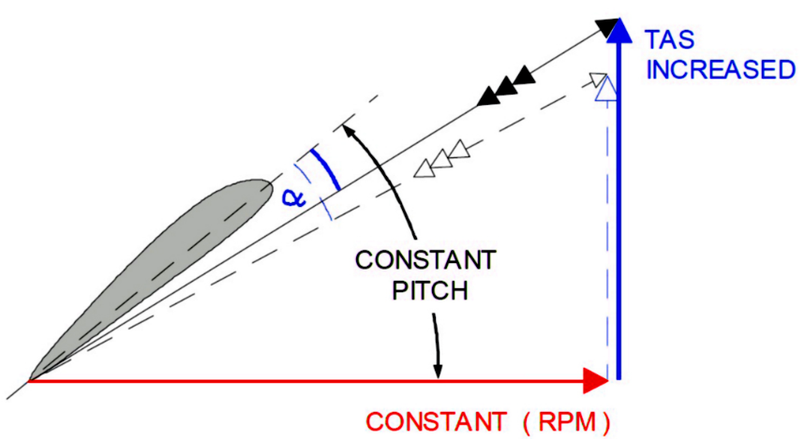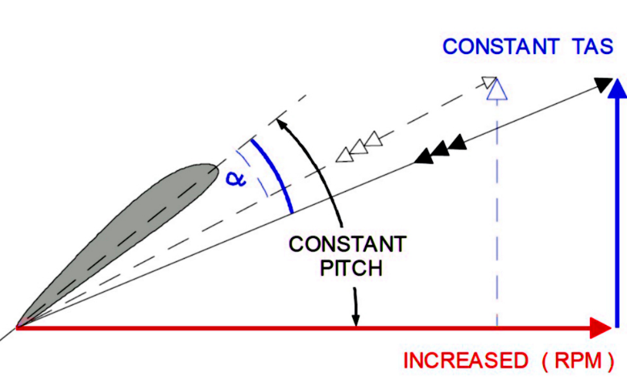**Propellers**

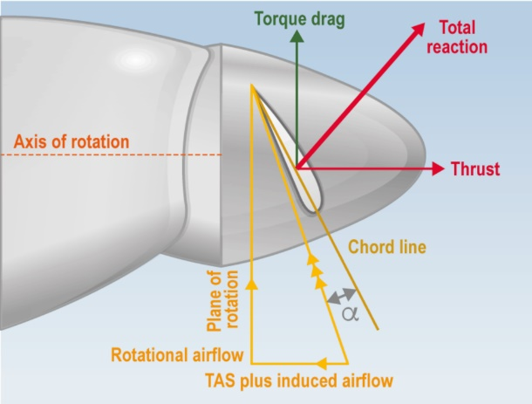

In a fixed pitch propeller blade AOA ↓ if: TAS ↑ RPM ↓ Thrust ↓

In a fixed pitch propeller blade AOA ↑ if: TAS ↓ RPM ↑ Thrust ↑

At a given RPM the propeller efficiency of a fixed pitch propeller is maximum at only 1 t=value of TAS

The centrifugal force tends to decrease AOA of a propeller

Fine pitch [decrease blade pitch angle] = centrifugal twisting moment   
Coarse pitch [increase blade pitch angle] = aerodynamic twisting moment

**Efficiency of a propeller** = $\frac{Thrust*TAS}{Torque*RPM}=\frac{usable power}{shaft power}$

In a **constant speed propeller**, if TAS ↑: blade angle ↑ RPM = constant

Thrust increases away from the root (where is low), but reduces back to zero at the tips

In the case of a high-speed glide, it is possible that the TAS increases so much that the blade AOA becomes negative.

Blue Lever:

* Forward: Fine (Small AOA) Drag ↑ ROD ↑
* Backward: Coarse (Large AOA) Drag ↓ ROD ↓

In a glide if TAS = constant and RPM lever ↑ (request more RPM), blade pitch ↓ (fine) and ROD ↑ (Efficiency ↓ as Drag ↑)

**Prop AOA**: angle between blade chord line | relative airflow   
**Blade angle**: angle between blade chord line | plane of rotation   
**Helix angle**: angle between actual path of the prop | plane of rotation [only angle not referenced to the chord]  
**Geometric pitch**: theoretical distance travelled in 1 revolution at zero blade AOA **Effective pitch**: actual distance a propeller advances in 1 revolution

AOA + Helix = Blade Angle

In a propeller if chord ↑ or # of blades ↑: Efficiency ↓ and Power absorption ↑

Icing on a propeller occurs first at the leading edge and thrust may decrease from 10% (normal) to 20% (severe)

Operating at constant RPM, the engine torque is the same as the propeller torque

In the event of an engine failure in a multi engine aircraft, extension of the flaps increases the roll

In the event of an **engine failure** in a multi engine aircraft you have to **roll and yaw towards the live engine.** Rudder balances the moment created by the live engine, but creates a sideways force toward the dead one. Roll to the live engine is done to balance that sideways. If the sideslip angle is too large, the fin could stall.

In the event of an **engine failure** in a multi engine aircraft, the **slipstreamed-induced lift will be lost** on the side with the failed engine

In the event of an **engine failure** in a multi engine aircraft the critical engine is the one where the wind comes from

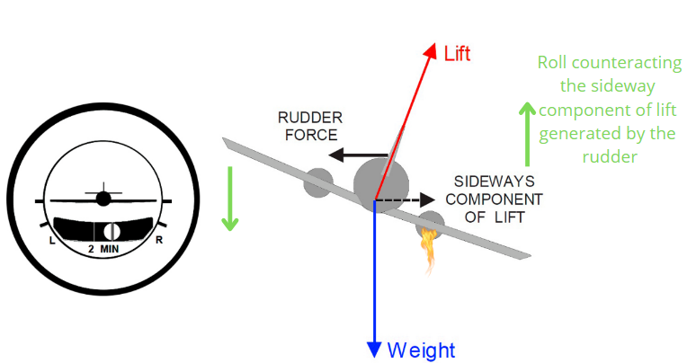**Increase** in aircraft **weight** **increase** (slightly) **rudder effectiveness** because of a **greater sideslip**

Feathered propeller angle ≅ 90°

Solidity is the ratio between the total frontal area of all blades to S (frontal area of 1 propeller disc)

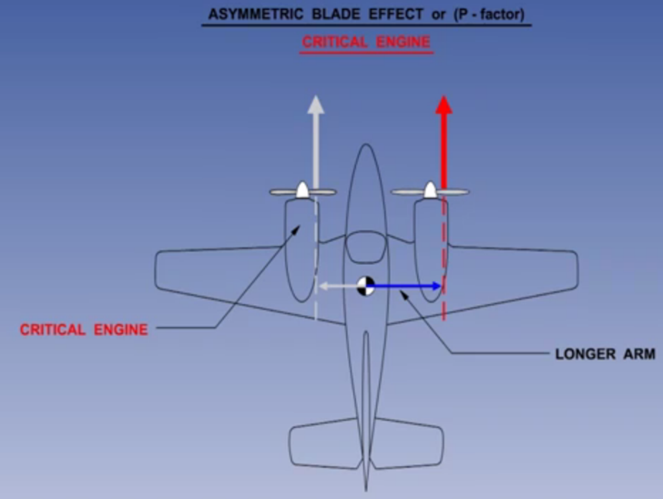Gyroscopic effect (precession) on clockwise turning engine:

* Nose up pitch = right yaw moment
* Nose down pitch = left yaw moment
* Left yaw command = nose up pitch moment
* Right yaw command = nose down pitch moment

**Asymmetric thrust:**

* Down going blade generate more thrust
* Up going blade generate less thrust
* The combination of the effects gives a left yawing moment

Asymmetric blade effect is greatest at high power and high AOA

**Critical engine** is the one generating more moment in the event of an engine failure (down going wing generates more thrust and consequently more moment): [generally the engine turning inwards is critical]

* 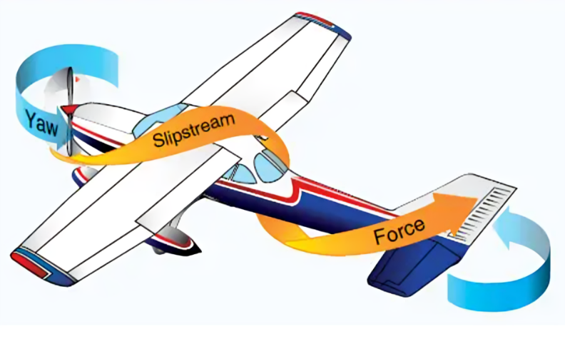Clockwise: left engine
* Counter clockwise: right engine

In the event of a **negative AOA** (CW rotation), the **Up going blade** generate more thrust, giving **right yawing moment**. This is the opposite of what happens **normally**, where is the **down going blade** that generate more thrust, giving a **left yawing moment** (e.g. during takeoff we need right rudder to compensate for this)

* Torque → During Taxi (Opposite to engine rotation)
* Slipstream effect → Take Off (Tail still on Ground)
* Gyroscopic effect → Take Off (Rotating - Pitch - Raising Tail - Tail on Air)
* Asymmetric thrust → Go Around (Yaw due to engine moment: CW = left yaw | ACW = right yaw)

2 propellers rotating in opposite directions on the same engine shaft are: contra-rotating propellers

If 2 propellers are counter rotating inwards, in case of engine failure it is the most favorable situation because the arm is the shortest possible

A propeller located ahead of an airplane’s CG creates a pitch-up moment, which means the nose of the aircraft tends to rise. This is a destabilizing effect, as it can cause the aircraft to stall or enter a spin.

**Flight mechanics**

**Radius of a turn** [m] = $\frac{TAS^{2}}{g*\tan\left(bank angle\right)}$ [TAS in m/s] | Turning radius is not influenced by Mass

During a turn, climb gradient will decrease and the induced drag increases proportionally to: CDi α CL2

During a pushover maneuver load factor < 1

In a glide, ROD is independent from the wind and can be calculated using TAS.

Gliding distance can be calculated using GS.

**Thrust in climb** = D + W*sinα (esubero di thrust usato per salire)   
**Thrust in descent** = D - W*sinα

With respect to a higher airspeed turn, a lower airspeed turn requires a lower bank angle and consequently turn radius decreases

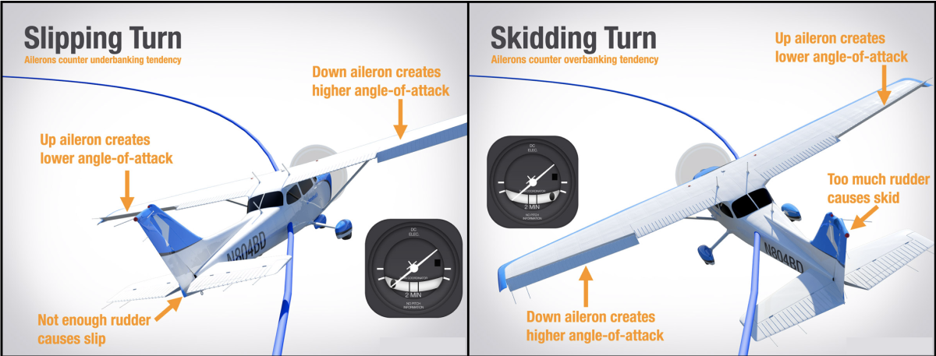

In a skidding turn, rudder is too much and bank angle is too low

ROD of an aircraft descending at VMD and slowing down will decrease until VMP is reached, then increase

Glide angle is fixed once configuration and AOA are determined. It is independent from mass

**Centripetal force** in a coordinated bank turn is L*sin(bank angle) | W*tan(bank angle)

Climb/descent gradient = sin(angle of climb)

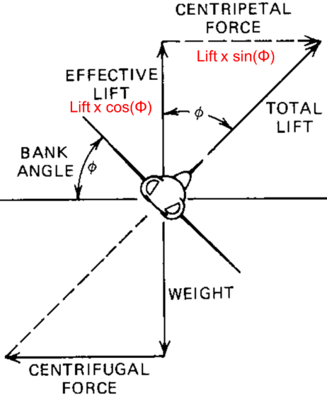**N (load factor)** = cos (angle of climb) | N = cos[sin-1(climb/descent gradient)]

|  |
| --- |
| Example  20% climb gradient  Angle of climb = sin-1(climb/descent gradient) = sin-1(0.2) = 11,54  N = cos (11.54) = 0,98 |

Pitch = AOA + FPA

In a climb with constant pitch:

* IAS ↓
* FPA ↓
* AOA ↑

Limit load factor is based on its maximum design mass

The force exerted by the rudder in asymmetric flight is affected by:

* Rudder deflection
* CG
* IAS

In asymmetric flight, yawing towards the live engine (not using ailerons) causes sideslip and ‘’side force on the fuselage’’ behind the CG and opposite to the rudder force. Using rudder to yaw towards the live engine doesn't mean getting the aircraft straight in relation to its flight path, it means yawing past that, exposing the part of the fuselage behind the CG and opposite to the rudder deflection.

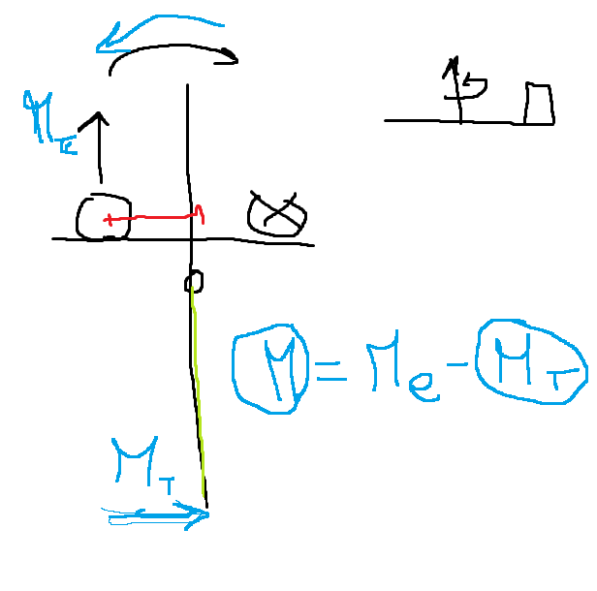Asymmetric yaw = Yaw from live engine + yaw from rudder due to sideslip angle along longitudinal axis

When on the ground, during take-off and landing predominantly, the aircraft will naturally want to turn into the crosswind, a process called **weathercocking**, that is brought on by the stabilizing effect of the tail fin.

The **worst situation** for **handling** during an **engine failure** is having **crosswind** on the **same side as the failed engine** as the wind on the fin would generate a moment towards the dead engine, increasing the required yaw correction

After engine failure:

* Equilibrium of moments about normal axis = rudder
* Equilibrium of force along lateral axis = bank (aileron), sideslip or a combination of both.